Regular and irregular(event)

Follows Line protocol

Introduction

Time series data is data that is collected at different points in time. This is opposed to cross-sectional data which observes individuals, companies, etc. at a single point in time.

Because data points in time series are collected at adjacent time periods there is potential for correlation between observations. This is one of the features that distinguishes time series data from cross-sectional data.

|  |  |  |
| --- | --- | --- |
| What Is an Example of Time Series Data? | | |
| **Field** | **Example topics** | **Example dataset** |
| Economics | Gross Domestic Product (GDP), Consumer Price Index (CPI), S&P 500 Index, and unemployment rates | [U.S. GDP from the Federal Reserve Economic Data](https://fred.stlouisfed.org/series/GDP) |
| Social sciences | Birth rates, population, migration data, political indicators | [Population without citizenship from Eurostat](https://ec.europa.eu/eurostat/tgm/table.do?tab=table&plugin=1&language=en&pcode=tps00157) |
| Epidemiology | Disease rates, mortality rates, mosquito populations | [U.S. Cancer Incidence rates from the Center for Disease Control](https://wonder.cdc.gov/cancer-v2015.html) |
| Medicine | Blood pressure tracking, weight tracking, cholesterol measurements, heart rate monitoring | [MRI scanning and behavioral test dataset](https://openneuro.org/datasets/ds002151/versions/1.0.0) |
| Physical sciences | Global temperatures, monthly sunspot observations, pollution levels. | [Global air pollution from the Our World in Data](https://ourworldindata.org/air-pollution) |

Modeling Time Series Data

Time series models are used for a variety of reasons -- predicting future outcomes, understanding past outcomes, making policy suggestions, and much more. These general goals of time series modeling don’t vary significantly from modeling cross-sectional or panel data. However, the techniques used in time series models must account for time series correlation.

Time-Domain Versus Frequency Domain Models

Two broad approaches have developed for modeling time series data, the time-domain approach and the frequency domain approach.

The time-domain approach models future values as a function of past values and present values. The foundation of this approach is the time series regression of present values of a time series on its own past values and past values of other variables. The estimates of these regressions are often used for forecasting and this approach is popular in time series econometrics.

Frequency domain models are based on the idea that time series can be represented as a function of time using sines and cosines. These representations are known as Fourier representations. Frequency domain models utilize regressions on sines and cosines, rather than past and present values, to model the behavior of the data.

Why InfluxDB?

* Easy to get started with
* Familiar query language
* No external dependence

What is a time series graph?

A time series graph plots observed values on the y-axis against an increment of time on the x-axis. These graphs visually highlight the behavior and patterns of the data and can lay the foundation for building a reliable model.

Time Series Visualization

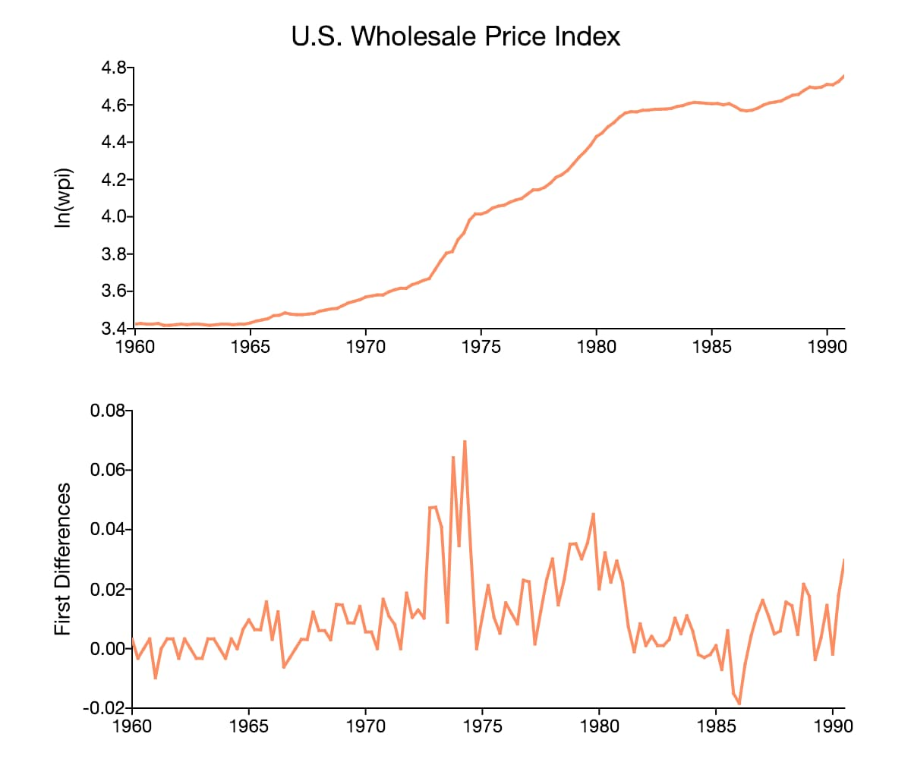

Reference

<https://www.youtube.com/watch?v=rRoy6I4gKWU>

<https://www.aptech.com/blog/introduction-to-the-fundamentals-of-time-series-data-and-analysis/>

<https://www.influxdata.com/university/>

<https://www.youtube.com/watch?v=o9WM37Gcnus&t=408s>

<https://www.youtube.com/watch?v=OoCsY8odmpM>

<https://www.youtube.com/watch?v=HB9bG3Qcvq8>

https://youtu.be/2SUBRE6wGiA?list=PLSE8ODhjZXjY0GMWN4X8FIkYNfiu8_Wl9